MED D - Blue MedicareRx (NEJE) - RxEnroll Care

How to Access RxEnroll Care
TRC 127
LEP Attestation
When an Address Update is Needed Reference Chart
Address Changes
Out of Area/Incarcerated
Related Documents

Description: The document assists the Blue MedicareRx (NEJE) CCR with using the RxEnroll Care application.

How to Access RxEnroll Care

Perform the steps below:
Step | Action
1 | Navigate to the Medicare D tab in PeopleSafe.
2 | Review the Participant Details Screens to identify if the beneficiary has any enrollment action that need to be completed. If action is required, the RxEnroll Care Action Needed will display.  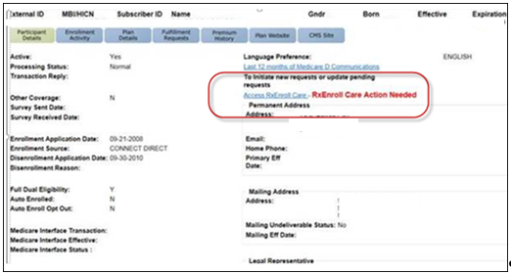
2 | If RxEnroll Care Action Needed is... | Then...
2 | Not Visible | No further action is needed
2 | Visible | Select Access RxEnroll Care.  Result: The RxEnroll Care screen will display.  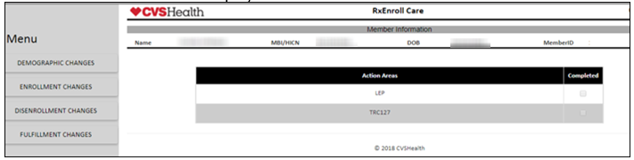
3 | Review the Action Areas section of the screen.  Note: When a process has been completed, the system will indicate that in the check box to the right of the task.  Note: If there are no items under Action Areas, the user can access the LEP or TRC 127 screens via the Menu on the left under Enrollment Changes
3 | If... | Then...
3 | TRC 127 | Refer to TRC 127.
3 | LEP | Refer to LEP Attestation.
Top of the Document

TRC 127
Notes:
- NEJE CCRs - Follow the process outlined in this document.
- In the event RxEnroll is unavailable/down, refer to MED D - Blue MedicareRx (NEJE) - Enrollee Attestation for Future Enrollment (TRC 127 Attestation).

Perform the steps below:
Step | Action
1 | Authenticate the caller.  Refer to the following documents:  - Caller Authentication  - HIPAA Authentication Grid  - MED D - Obtaining a Verbal Attestation from an Authorized Representative
2 | Select TRC127.  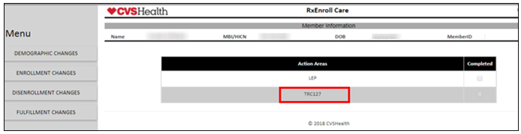  Result: The appropriate Enrollment Confirmation will display depending on the beneficairy’s enrollment status.
2 | If the beneficiary has submitted an application for individual coverage but is already enrolled in an EGWP and... | Then...
2 | Has NOT attested to which coverage they want | - Read statement provided in RxEnroll to the beneficiary.  - Is the beneficiary’s intent to be enrolled with Blue MedicareRx effective <date>?
2 | Has NOT attested to which coverage they want | If... | Then…
2 | Has NOT attested to which coverage they want | No | - Select Decline Enrollment.  - Enter the following Comments in the pop up box: Beneficiary declines enrollment due to <Reason>.  - Read statement provided on pop-up to the beneficiary.  Result: The following pop-up will display.  Note: Copy and Paste comments into the Participant Inquiry Tab in PeopleSafe.  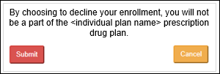  - Select Submit if the beneficiary confirms their decision.  - Once submitted, the RxEnroll Care screen will display, showing the process has been completed.
2 | Has NOT attested to which coverage they want | Yes | - Select Continue Enrollment.  - Enter the following Comments in the pop up box: Beneficiary accepts enrollment.  - Read statement provided on pop-up to the beneficiary.  Result: The following pop-up will display.  Note: Copy and Paste comments into the Participant Inquiry Tab in PeopleSafe.  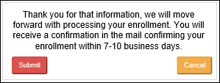  - Select Submit if the beneficiary confirms their decision.  - Once submitted, the RxEnroll Care screen will display, showing the process has been completed.
2 | Attested to continue enrollment in the individual plan  OR  Already enrolled in that plan | - Read statement provided in RxEnroll to the beneficiary.  - Is the beneficiary’s intent to be enrolled with <plan name> <effective date>?
2 |  | If... | Then…
2 |  | No | - Select Decline Enrollment.  - Enter the following Comments in the pop up box: Beneficiary declines enrollment due to <Reason>.  - Read statement provided on pop-up to the beneficiary.  Result: The language contained on pop-up will vary based on the beneficiary’s current application or enrollment status.  Note: Copy and Paste comments into the Participant Inquiry Tab in PeopleSafe.  - Select Submit if the beneficiary confirms their decision.
2 |  | No | If system indicated to submit... |  | Then…
2 |  | No | 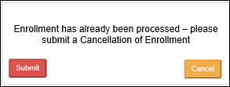 |  | Refer to MED D - Cancellation of Enrollment
2 |  | No | 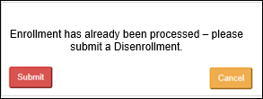 |  | Refer to:  - MED D - Blue MedicareRx (NEJE) Voluntary Disenrollment
2 |  | Yes | - Select Continue Enrollment.  - Enter the following Comments in the pop up box: Beneficiary accepts enrollment.  - Read statement provided on pop-up to the beneficiary.  Result: The following screen will display.  Note: Copy and Paste comments into the Participant Inquiry Tab in PeopleSafe.  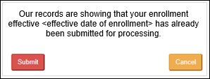  - Select Submit if the beneficiary confirms their decision.
2 | May not cancel this enrollment due to already submitted a cancellation or the grace period has ended | - Read statement provided in RxEnroll to the beneficiary.  - Is the beneficiary’s intent to be enrolled with <plan name> <effective date>?
2 |  | If... | Then…
2 |  | No | - Select Decline Enrollment.  - Enter the following Comments in the pop up box: Beneficiary declines enrollment due to <Reason>.  - Read statement provided on pop-up to the beneficiary.  Result: The following screen will display.  Note: Copy and Paste comments into the Participant Inquiry Tab in PeopleSafe.  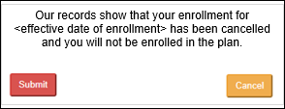  - Select Submit if the beneficiary confirms their decision.
2 |  | Yes | - Select Continue Enrollment.  - Enter the following Comments in the pop up box: Beneficiary accepts enrollment.  - Read statement provided on pop-up to the beneficiary.  Result: The following screen will display.  Note: Copy and Paste comments into the Participant Inquiry Tab in PeopleSafe.  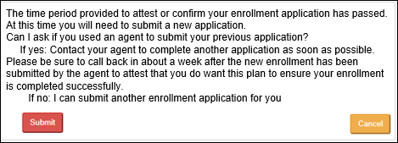  - Select Submit if the beneficiary confirms their decision.
2 |  | Yes | If... | Then...
2 |  | Yes | Yes | Contact your agent to complete another application as soon as possible. Please be sure to call back in about a week after the new enrollment has been submitted by the agent to attest that you do want this plan to ensure your enrollment is completed successfully.
2 |  | Yes | No | Assist beneficiary with enrollment application.

Top of the Document

LEP Attestation
Notes:
- NEJE CCRs - Follow the process outlined in this document.
- In the event RxEnroll is unavailable/down, refer to MED D - Blue MedicareRx (NEJE) - Enrollee Attestation for Future Enrollment (TRC 127 Attestation).

Perform the steps below:
Step | Action
1 | Determine if an attestation has been submitted to CMS or the status of the CMS review by selecting View Comments.
1 | If... |  |  |  |  | Then...
1 | Has NOT been submitted |  |  |  |  | Offer verbal attestation via RxEnroll.
1 | Has been previously submitted, but now has new information to add |  |  |  |  | Offer verbal attestation via RxEnroll.
1 | Has been previously submitted and there is NO new information to add |  |  |  |  | Submit RM task for a Reconsideration Packet.  Refer to:  - MED D - Blue MedicareRx (NEJE) Late Enrollment Penalty (LEP)
2 | Select LEP.  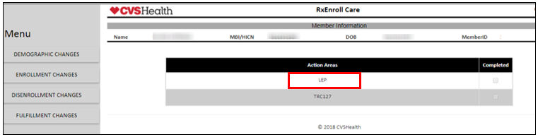  Result: The appropriate screen will display depending on when the beneficary calls.  Note: If LEP does not show under Action Areas, the user can access the LEP screen via the Menu on the left under Enrollment Changes.
2 | If today’s date is... |  |  |  | Then CCR will be directed to...
2 | Less than the reply by date +60 days on the original LEP notification letter |  |  |  | Proceed to Call Authentication Screen.
2 | Greater than the reply by date + 60 days on the original LEP notification letter |  |  |  | Untimely Attestation Screen.  - Access the LEP screen via Enrollment Changes from the Menu on the left. Enter the following Comments in the pop up box: Advised beneficiary is past the time frame to attest and beneficiary requested reconsideration packet.  - Enter comments regarding the beneficiary attempting to attest late. Note: If the beneficiary is requesting a replacement reconsideration packet, they will need to indicate that in the notes per the note below the comment box.  Note: Copy and Paste comments into the Participant Inquiry Tab and Medicare D Inquiry Tab in PeopleSafe.  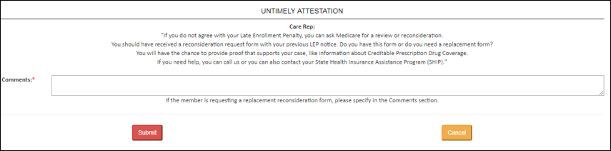
3 | Complete Call Authentication: To confirm, I am speaking with <Mr. /Mrs. beneficiary first and last name>.  Note: There is an option to select an authorized representative if the plan has one/any on file (it will be indicated above in the beneficiary details). There will be a drop down box to select the name of the caller if there is an authorized rep on file.  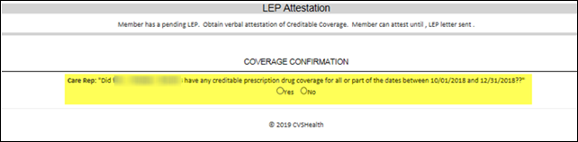
3 | If… | Then...
3 | Yes | - Select Yes.  - Read statement provided on pop-up to the beneficiary.  - Select Submit if the beneficiary confirms their decision.  Result: The Coverage Confirmation Screen will display.  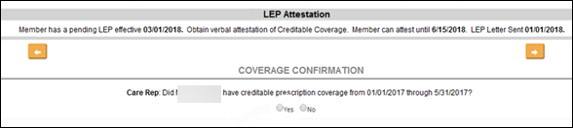  - Does <Mr./Mrs. beneficiary first and last name> have creditable prescription drug coverage for all or part of the dates between <date> and <date>?  - Select Yes if the beneficiary had coverage for all or part of the span shown under Coverage confirmation.  Note: If the beneficiary was residing outside of the country/service area OR if the beneficiary was incarcerated during the dates in his/her letter, this time span should be entered as creditable prescription drug coverage with coverage type “other”. Clearly notate PeopleSafe and RxEnroll Care to indicate the beneficiary should not be assessed an LEP during a timeframe that he/she did not qualify for enrollment in a Part D plan.
3 | Yes | If... | Then…
3 | Yes | Yes | - Select Yes.  - Read statement provided on pop-up to the beneficiary.  Result: The Attest Verbally Screen will display.  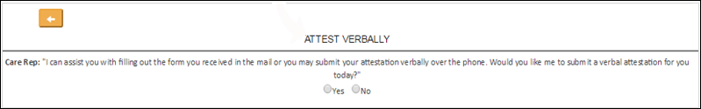  - Would the beneficiary like to submit a verbal attestation?
3 | Yes | Yes | If... | Then...
3 | Yes | Yes | Yes | - Select Yes.  - Read statement provided on pop-up to the beneficiary.  Result: The Coverage Details Screen will display.  - Enter the Coverage Start Date and End Date using the Calendar Tool and the type.  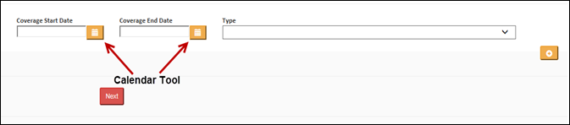  - Click the Calendar icon next to the date field.  - Select the year that coverage began/ended by clicking on the Month/Year at the top of the calendar.  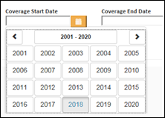  Note: Use the arrows to move the range of years.  - Select the month that coverage began/ended  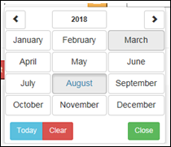  - Select the day of the month provided by the beneficiary.  Note: If the beneficiary only knows the month and year, select the 1st of the month indicated.  Result: The date will populate in the date field.  If the beneficiary is attesting that their coverage started in a year prior to the gap dates shown on the Coverage Details Screen, it is acceptable to use the start month/year of the Gap Start Date (shown below) as the Coverage Start Date.    Note: Multiple coverage gaps can be entered by selecting the button.  - Select Next.  Result: The Confirm Attestation screen will display.  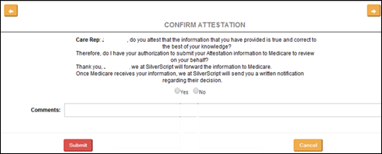  - Read statement provided on pop-up to the beneficiary.  - Does the beneficiary attest the information provided is true and correct to the best of their knowledge? And do you have their authorization to submit their Attestation information to Medicare to review?
 |  |  |  | If... | Then...
 |  |  |  | Yes | - Select Yes.  - Enter the following Comments in the pop up box: Beneficiary attests that all information provided is true and correct.  - If needed provided Legal Rep or POA (Full name, address, phone number, and relationship to the beneficiary).  - Select Submit if the beneficiary confirms their decision.  Note: Copy and Paste comments into the Participant Inquiry Tab and Medicare D Inquiry Tab in PeopleSafe.
 |  |  |  | No | - Select No.  - Enter the following Comments in the pop up box: Beneficiary does not attest that all information provided is true and correct.  - If needed provided Legal Rep or POA (Full name, address, phone number, and relationship to the beneficiary).  - Select Submit if the beneficiary confirms their decision.  Note: Copy and Paste comments into the Participant Inquiry Tab and Medicare D Inquiry Tab in PeopleSafe.
3 | Yes | Yes | No | - Select No.  - Enter the following Comments in the pop up box: Beneficiary does not want to provide verbal attestation due to <Reason>.  - If needed provided Legal Rep or POA (Full name, address, phone number, and relationship to the beneficiary).  - Select Submit if the beneficiary confirms their decision.  Note: Copy and Paste comments into the Participant Inquiry Tab and Medicare D Inquiry Tab in PeopleSafe.
3 | Yes | No | - Select No.  - Read statement provided on pop-up to the beneficiary.  - Select Submit if the beneficiary confirms their decision.  Result: The No Coverage Screen will display.  - Does the beneficiary or authorized rep attest the information that has been provided is true and correct to the best of their knowledge? And do I have your authorization to submit your Attestation information to Medicare to review on your behalf?
3 | Yes | No | If... | Then...
3 | Yes | No | Yes | - Select Yes.  - Enter the following Comments in the pop up box: Beneficiary attests that all information provided is true and correct.  - If needed provided Legal Rep or POA (Full name, address, phone number, and relationship to the beneficiary).  - Select Submit if the beneficiary confirms their decision.  Note: Copy and Paste comments into the Participant Inquiry Tab and Medicare D Inquiry Tab in PeopleSafe.
3 | Yes | No | No | - Select No.  - Enter the following Comments in the pop up box: Beneficiary does not attest that all information provided is true and correct.  - If needed provided Legal Rep or POA (Full name, address, phone number, and relationship to the beneficiary).  - Select Submit if the beneficiary confirms their decision.  Note: Copy and Paste comments into the Participant Inquiry Tab and Medicare D Inquiry Tab in PeopleSafe.
3 | No | - Select No.  - Select Submit if the beneficiary confirms their decision.  Result: The Authorized Representative Screen will display.  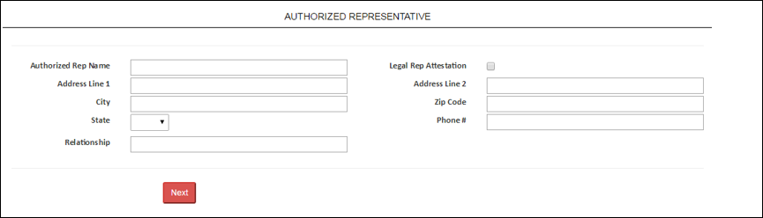  - Enter the following information:  - Authorized Rep Name  - Legal Rep Attestation  - Address Line 1  - Address Line 2  - City  - State  - Zip Code  - Phone #  - Relationship  Examples:  - Address Line 1: Street number and Street name (123 Main St.)  - Address Line 2: Apartment Number, Lot Number and C/O information (Apt 2, Lot 15, C/O John Deere)  Note: The address lines have a 30 character limit.  - Select Next.
3 | No | If Legal Rep Attestation is... | Then CCR will be directed to the…
3 | No | Checked | Coverage Confirmation screen.
3 | No | Not Checked | Contact Information Screen with direction to read the following to the caller:  Only the beneficiary or legal representative or SHIP Counselor is able to verbally attest.  You can assist the beneficiary in filling out the verbal attestation form to be mailed to:  Blue MedicareRx  P.O BOX 30001  Pittsburgh, PA 15222-0330  OR fax to: JE Fax (866) 342-7048
3 | Unable to obtain information | - Select Unable to obtain information.  - Enter the following Comments in the pop up box: Unable to obtain LEP information.  - Select Submit if the beneficiary confirms their decision.  Note: Copy and Paste comments into the Participant Inquiry Tab and Medicare D Inquiry Tab in PeopleSafe.

Top of the Document

When an Address Update is Needed Reference Chart

Refer to the following:
Address Change Scenarios | Update Permanent Address in Fulfillment screen in Med D Tab (RM Task Required) | Update Mailing Address in Fulfillment screen in Med D Tab  (RM Task Required) | Update Participant Inquiry Address (Prescription)
Beneficiary Confirming Permanent (Home/Residential) and/or Mailing address on file | N/A | N/A | N/A
Single Use/Single Fill | N/A | N/A | Add alternate address with same start and end date of single fill prescription order
Temporary/Alternate | N/A | Update mailing address | Add alternate address with a start and end date
Mail Order | N/A | N/A | Add Primary address.
Mailing/Mail Order | N/A | Update address | Add New address
Mailing (no Mail Order) | N/A | Update address | Confirm address
Permanent (Home/Residential) (no Mail Order) | Update address | N/A | Confirm address
Permanent (Home/Residential) /Mailing/Mail Order | Update address | Update address | Add New address
Out of the Country | Update address using FN for the State Code | Add New address for out of the country using FN for the State Code | Add New address using EU for the State Code
Incarcerated | N/A | N/A | N/A

Top of the Document

Address Changes
Note: For all address changes or if the beneficiary is moving to a Long Term Care (LTC)/Assisted Living Facility (ALF)/Nursing Home review the client code and process accordingly.
- NEJE CCRs - Follow the process outlined in this document.
- In the event RxEnroll is unavailable/down, refer to MED D - RxEnroll Care Downtime Procedures - Address Changes and Out of Area (OOA).

Perform the steps below to complete an Address change in RxEnroll Care:
Step | Action
1 | Select Demographic Changes.  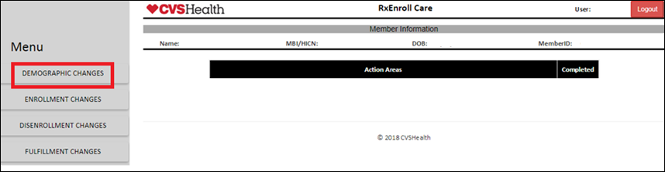  Note: If any lines appear under the Action Areas banner, refer to the work instructions for that task type (LEP, TRC127, etc.).  Result: The Address Information Screen will display.
2 | Read the language under the Address box.  Notes:  - If the beneficiary is incarcerated, check the Note: If the beneficiary is incarcerated, please check the box.  - If beneficiary has an Out of Area task pending, the system will display that under the Address Information banner.  Refer to MED D - Address Changes and Out of Area (OOA).  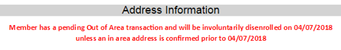
3 | Verify the Address(es) on file
3 | If... | Then...
3 | Address is correct and does NOT need to be updated | - Select the [address type] on file is correct box below the address.  - Select Next.  - Proceed to next step.
3 | Address requires updates | - Select Next.  - Proceed to next step.
3 | Beneficiary would like to cancel at any time during the call | - Select Cancel.  - Read the language presented in the pop up box.  - Enter the following Comments in the pop up box: Beneficiary advised to cancel address change due to <Reason>.  - If needed provided Legal Rep or POA (Full name, address, phone number, and relationship to the beneficiary).  - Click Submit.  - Log out of the RxEnroll Care application.
4 | Read the language presented under the Address Updates banner.  Based on the response, update the Permanent (Home/Residential) AND/OR mailing address  - If both addresses are being updated and the mailing matches the permanent, select the checkbox Mailing address same as permanent address.  - If the date the beneficiary will be moving to the new Permanent (Home/Residential) address is different than the date the system populates, click the calendar icon next to Effective Date to select the correct date.  - If the Permanent (Home/Residential) address change is OOA, the Effective Date will determine the disenrollment effective date with the plan.  For mailing or temporary address changes, do NOT add an Effective Date. This date will not be transferred between systems.  - If the address include 1/2, then refer to MED D - RxEnroll Care Downtime Procedures - Address Changes and Out of Area (OOA) to submit an RM Task. Add the following note in comments: Unable to update address via RxEnroll Care with this scenario  Examples:  - Address Line 1: Street number and Street name (123 Main St.)  - Address Line 2: Apartment Number, Lot Number and C/O information (Apt 2, Lot 15, C/O John Deere)  Reminder: Permanent (Home/Residential) Address requires a physical street address (P.O. Box is not allowed for permanent address.)  Notes:  - Depending on the address information entered, a box may pop up with a recommended address from the USPS. If you wish to accept the recommendation, click the Override [address type] address box.  - Email and phone updates are allowed if those fields DO NOT have prepopulated data. Refer to MED D - Email and Phone Number Changes work instruction.  - The address lines have a 30 character limit.
5 | Read confirmation language under the address update area.
5 | If... | Then...
5 | Agrees | - Select Yes radio button.  - Select Next.  - Proceed to next step.
5 | Does not agree | - Select No radio button  - Enter the following Comments in the pop up box: Beneficiary does not agree to address change due to <Reason>.  - If needed provided Legal Rep or POA (Full name, address, phone number, and relationship to the beneficiary).  - Click Submit.  - Log out of the RxEnroll Care application.
6 | Read the language presented on the screen.
6 | If... |  | Then...
6 | Updated In-Area address |  | May I assist you with anything else today?
6 |  |  | If... | Then...
6 |  |  | Yes | - Select Yes radio button.  - Proceed to Close the call.
6 |  |  | No | - Select No radio button  - Enter the following Comments in the pop up box: Beneficiary has no additional comments/concerns/special circumstances.  - If needed provided Legal Rep or POA (Full name, address, phone number, and relationship to the beneficiary).  - Click Submit.  - Log out of the RxEnroll Care application.
6 | Updated Out-of-Area address |  | Read the language presented on the screen. Refer to MED D - Address Changes and Out of Area (OOA).
7 | Ask the beneficiary to allow you a few moments to update the other systems before you close the call or transfer the beneficiary to another department.
8 | Obtain Capture and Log Activity Note information.  - From the Medicare Inquiry Tab, copy the old Address(es) into Notepad.  - Click on the Medicare Inquiry Tab to refresh Address(es).  - Copy the new updated Address(es) into Notepad to use for your final Capture and Log Activity note.

Top of the Document

Out of Area/Incarcerated
Note: For all out of area changes or if the beneficiary is moving to a Long Term Care (LTC)/Assisted Living Facility (ALF)/Nursing Home review the client code and process accordingly.
- NEJE CCRs - follow the process outlined in this document.
- In the event RxEnroll is unavailable/down, refer to MED D - RxEnroll Care Downtime Procedures - Address Changes and Out of Area (OOA)
Perform the steps below:
Step | Action
1 | Click the Access RxEnroll Care link located on the Participant Details screen of the Medicare D Inquiry tab in PeopleSafe:  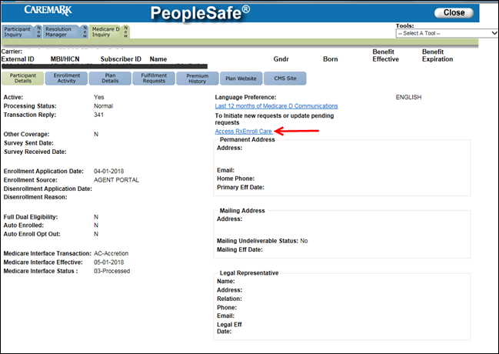  Result: RxEnroll Care screen displays.  Note: If there are additional tasks listed under Action Areas, reference the appropriate work instruction to resolve the task for the beneficiary before ending the call.
2 | Determine if the beneficiary has a pending Out of Area case.
2 | If... |  |  | Then...
2 | Yes |  |  | Select OOA under Action Areas.
2 | No, but the beneficiary requests to update address information |  |  | - Select Demographic Changes.  - Click on Address Updates.  Result: The Address Information screen displays with the current address information on file for the beneficiary.
3 | Review the addresses on file with the beneficiary and determine which addresses need to be updated.  Note: If there is a pending OOA case for the beneficiary, it will display the date in red below the Address Information heading in which the beneficiary needs to confirm his/her Permanent (Home/Residential) address in order to avoid disenrollment. If an address update is not made, the beneficiary will continue to clock and will be disenrolled as of the date indicated.
3 | If... |  |  |  |  |  | Then...
3 | Permanent (Home/Residential) address is correct |  |  |  |  |  | - Check the Permanent address on file is correct box below the permanent address.  - Click Next.  Result: The Permanent Address field will be grayed out in the address update screen.
3 | Mailing address is correct |  |  |  |  |  | - Check the Mailing address on file is correct box below the mailing address.  - Click Next.  Result: The Mailing Address fields will be greyed out in the Address Update screen.
3 | Both the Permanent (Home/Residential) and Mailing address are correct |  |  |  |  |  | - Check the Permanent address on file is correct box below the permanent address.  - Check the Mailing address on file is correct box below the mailing address.  - Click Next.
3 | Both the Permanent (Home/Residential) and Mailing address need to be updated |  |  |  |  |  | - Do not check the boxes below the addresses.  Result: The Address Update screen will display.  - Proceed to next step.
3 | Beneficiary is incarcerated |  |  |  |  |  | - Check the box next to Note: If the beneficiary is incarcerated, please check this box.  Result: The Address Update Incarceration screen will display.  - Confirm the caller’s identity and obtain the information requested on the Incarceration screen in RxEnroll.  - Enter the following information:  - Caller’s Name  - Start date of Incarceration period  - End date of incarceration period, if available  - State in which the beneficiary is incarcerated  - Review the message with the caller that the beneficiary will need to reenroll in a Part D plan upon release  - Click Next.  Result: The RxEnroll Care main page will display and no further action is required.  Note: All incarceration tasks will be researched fully by an enrollment specialist to confirm incarceration prior to a disenrollment being processed. Clicking Next will not automatically disenroll the beneficiary but will submit the request for research.
3 | Beneficiary is Out of the Country |  |  |  |  |  | - Confirm the caller’s identity and obtain the information requested on the care screen in RxEnroll.  - Enter the following information:  - Caller’s Name  - Date of move out of the Country  - Review the message with the caller that the beneficiary will need to reenroll in a Part D plan upon return to the Country.  - Click Next.
4 | Determine if the address change is a Permanent (Home/Residential) or mailing address, by review the message displayed under the address update.
4 | If... |  |  |  |  | Then...
4 | Mailing Address Change |  |  |  |  | Populate all fields under the Mailing Address.  - Address 1*  - Address 2  - City*  - State* (if the move is a foreign move, select FN from the dropdown menu)  - Zip*  Examples:  - Address Line 1: Street number and Street name (123 Main St.)  - Address Line 2: Apartment Number, Lot Number and C/O information (Apt 2, Lot 15, C/O John Deere)  Notes:  - An Asterisk (*) indicates a mandatory field.  - If the mailing address is the same as the permanent address, check the Mailing address same as permanent address box to auto populate all fields.  - The address lines have a 30 character limit.
4 | Permanent (Home/Residential) Address Change |  |  |  |  | Populate all fields under the Permanent Address Section.  - Address 1*  - Address 2  - City*  - State* (if the move is a foreign move, select FN from the dropdown menu)  - Zip*  - Email  - Phone  Examples:  - Address Line 1: Street number and Street name (123 Main St.)  - Address Line 2: Apartment Number, Lot Number and C/O information (Apt 2, Lot 15, C/O John Deere)  Notes:  - An Asterisk (*) indicates a mandatory field.  - The address lines have a 30 character limit.  Reminder: The complete Permanent Address CAN NOT be a P.O. Box.
5 | Confirm the address change(s) with the beneficiary and review the message on the screen to advise the beneficiary that if the mailing address is being used on a temporary basis, they will need to contact the plan to update their records when there is a change.
6 | Does the beneficiary agree to proceed?
6 | If... | Then...
6 | Yes | Select Yes.  Result: The system will run the addresses through the US Postal Service Perfect Address database. This service will check the new address and provide suggestions if a typographical error was made, or if the address does not match the database.
6 | Yes | If the address... |  |  |  |  |  | Then...
6 | Yes | Matches the Perfect Address Database |  |  |  |  |  | Select Accept and Continue.
6 | Yes | Does not Match the Perfect Address Database |  |  |  |  |  | Reconfirm the address with the beneficiary.  Note: If the address being given by the beneficiary is not found in the Perfect Address database, override the suggestions using the “Override [address type] box below each address and use the address being provided by the beneficiary.
6 | No | Select No.
7 | RxEnroll Care determines:
7 | If... |  |  |  | Then...
7 | New address is in area |  |  |  | The Address Update - In Area screen will display.  - Review the message with the beneficiary to let them know that their address has been updated.  - Proceed to Step 8.
7 | New address is out of area and no plan is available due to foreign address or no plan is available in new region |  |  |  | The OOA Disenrollment screen will display.  - Review the message displayed within RxEnroll Care with the beneficiary to advise them of their upcoming disenrollment.  - Leave comments to indicate what actions were taken and any pertinent information (mandatory)  Note: Enter appropriate comments into RxEnroll and copy and paste into the Participant Inquiry Tab in PeopleSafe.  If NOT Incarcerated:  - Old permanent address: Address1, address2, city, state, zip. New permanent address is: Address1, address2, city, state zip. Effective on: MM/DD/YYYY. Ending on (if applicable): MM/DD/YYYY. Old mailing address: Address1, address2, city, state, zip New Mailing address is: Same as permanent (put x here) or address1, address2, city, state zip. Effective on: MM/DD/YYYY. Ending on (if applicable): MM/DD/YYYY. Caller is (if not the beneficiary).  - If needed provided Legal Rep or POA (Full name, address, phone number, and relationship to the beneficiary)  If Incarcerated:  - Caller is <Fist Name Last Name>, <DOB>, Date incarceration began: MM/DD/YYYY Date incarceration ends (if applicable): MM/DD/YYYY Facility Name: Incarceration State.  - If needed provided Legal Rep or POA (Full name, address, phone number, and relationship to the beneficiary)
7 | Beneficiary is an auto enrollee who has moved to a region below the benchmark |  |  |  | The Address Update - In Area screen will display.  - Review the message with the beneficiary to let them know that their address has been updated.  - Proceed to Step 8.
7 | New enrollment is required for the beneficiary’s new region |  |  |  | The New Enrollment Required screen will display  Review the message displayed within RxEnroll Care with the beneficiary indicating that a new enrollment is required to prevent a lapse in coverage.
7 |  |  |  |  | If beneficiary would like to ... |  |  |  | Then...
7 |  |  |  |  | Continue reenrollment in the new region |  |  |  | You will be disenrolled at the end of this month, to find a new plan you can go to www.medicare.gov or Call 1-800-633-4227 (1-800-MEDICARE) 24 hours a day, 7 days a week or visit www.medicare.gov to enroll. TTY users should call 1-877-486-2048.  - Phone number to provide to the beneficiary if requested is 1-833-606-0372.  - Leave comments to indicate what actions were taken and any pertinent information (mandatory)  Note: Enter appropriate comments into RxEnroll and copy and paste into the Participant Inquiry Tab in PeopleSafe.
7 |  |  |  |  | Does not want to continue reenrollment in the new region |  |  |  | Select No, member would like to be disenrolled.
7 |  |  |  |  | Disenroll |  |  |  | Review the message displayed in RxEnroll providing the beneficiary with the disenrollment effective date.  Note: If the beneficiary agrees with the action to disenroll  - Select Continue with disenrollment.  - Leave comments to indicate what actions were taken and any pertinent information (mandatory)  - Note: Enter appropriate comments into RxEnroll and copy and paste into the Participant Inquiry Tab in PeopleSafe.  - If NOT Incarcerated:  - Old permanent address: Address1, address2, city, state, zip. New permanent address is: Address1, address2, city, state zip. Effective on: MM/DD/YYYY. Ending on (if applicable): MM/DD/YYYY. Old mailing address: Address1, address2, city, state, zip New Mailing address is: Same as permanent (put x here) or address1, address2, city, state zip. Effective on: MM/DD/YYYY. Ending on (if applicable): MM/DD/YYYY. Caller is (if not the beneficiary).  - If needed provided Legal Rep or POA (Full name, address, phone number, and relationship to the beneficiary)  - If Incarcerated:  - Caller is <Fist Name Last Name>, <DOB>, Date incarceration began: MM/DD/YYYY Date incarceration ends (if applicable): MM/DD/YYYY Facility Name: Incarceration State.  - If needed provided Legal Rep or POA (Full name, address, phone number, and relationship to the beneficiary)  - If Permanent move is outside of the Country Beneficiary will be disenrolled from the plan. Refer to MED D - Address Changes and Out of Area (OOA).
8 | Ask the beneficiary if there is anything else you can help them with?
8 | If... |  | Then...
8 | Yes |  | - Select Yes.  - Ask additional probing questions to attempt to resolve remaining questions or concerns.  Result: The RxEnroll Care main page will display.
8 | No |  | - Select No.  - Ask additional probing questions to attempt to resolve remaining questions or concerns.  Result: The RxEnroll Care main page will display.

Top of the Document

Related Documents
Parent SOP: CALL-0048: Medicare Part D Customer Care Call Center Requirements-CVS Caremark Part D Services, L.L.C.
Abbreviations/Definitions: Abbreviations / Definitions

Top of the Document
Not To Be Reproduced Or Disclosed to Others Without Prior Written Approval
ELECTRONIC DATA = OFFICIAL VERSION – PAPER COPY = INFORMATIONAL ONLY

